
Practical Report
For IoT Practical

Darshan Ramjiyani (DSP)
DOCS, KSKV Kachchh University

- 5.6 – Simple Analog and Digital Input

- Arduino Code:

const int potPin = 0;
const int ledPin = 13;
int val = 0;

void setup()
{
pinMode(ledPin, OUTPUT);
}
void loop()
{
val = analogRead(potPin);
digitalWrite(ledPin, HIGH);
delay(val);
digitalWrite(ledPin, LOW);
delay(val);
}

- Output / Circuit Diagram:
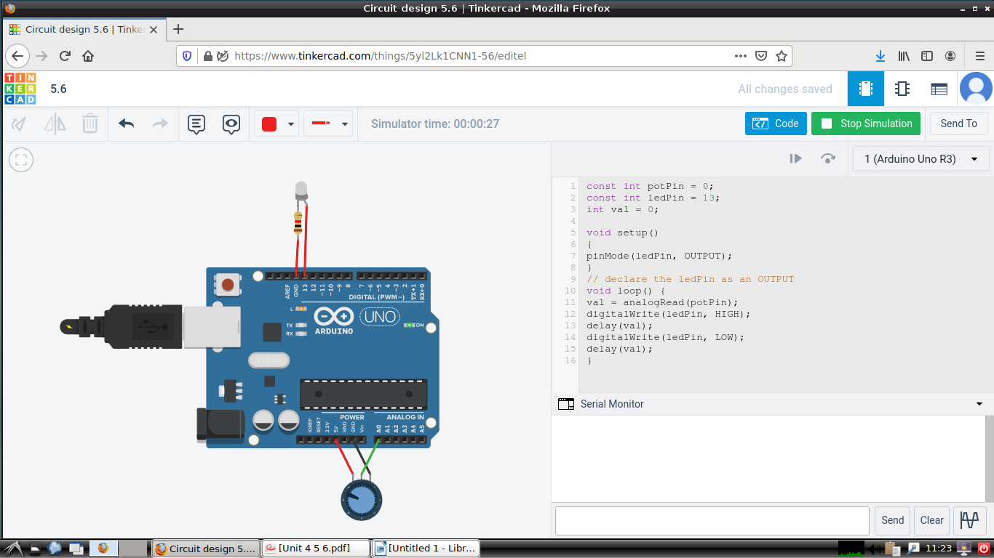
Darshan Ramjiyani

